Name : ___________________________________________ Date: ________

Autobiography Project 2016
The following information describes what will be included in your autobiography and the basic order in which you will complete your pages. More details about each section will be provided to you in class as we go through the project. Please be sure to keep this throughout the project.

General Notes:
- You will do the majority of the writing for this project prior to building the pages.
- Deadlines will be set for each piece of writing and should be adhered to so you will have plenty of time to complete the project.
- You can choose to type your writing at home if you wish. It is not required!
- Items below (except Content Pages) are pages that will be completed AT THE END of the project.
- You will be writing many personal narratives that will cover your life, including your First Years (birth to 4 years of age), Family, Friends, School, and Future. You will also have the opportunity to add any additional pages you choose once all required ones are complete!
- Each page in your book should have a title on it somewhere.

Creative Cover: Your autobiography will need a cover page that reflects you. The cover will depend on the type of book you purchased for the projects. Here are a few ideas:

- If you purchased a binder with a plastic cover, design a cover on a piece of computer paper. Slip it inside the plastic cover when it is done.
- If you purchased a binder without a plastic cover, a scrapbook with a plain cover, or a magnetic photo album with a plain cover you can use stickers to make it unique.
- If you purchased a scrapbook with a cover already done, you don’t need to do anything. However, you can add stickers to make it more personal.
- Options for everyone - Cut out pictures, magazine photos, computer clipart, etc. to use as a part of your cover.
- .
Title Page: This is the first page of your autobiography and should contain the following:
- Your full name
- Title (come up with your own)
- Published date (June 2016)
- Illustration(s)

Dedication Page: The second page in your autobiography is the dedication page. This should contain 1-2 paragraphs that dedicate your autobiography to those people that have been the most helpful to you during your life and/or during the completion of your project. You may also add an illustration to this page.
Table of Contents: The third page in your autobiography is the Table of Contents detailing what is in your autobiography. Although it is the third page it should be done LAST. This way you will know how many pages you have and how to number them. It will contain the following:
- Table of Contents - written at the top of the page and centered
- Page titles and page numbers (in the order in which they appear in your book)

Conclusion: Your conclusion will be the last page and may take any form you wish. Here are some options to guide you in your decision:
- Write a poem or a paragraph that best describes you and your thoughts after finishing the project. What were your feelings about doing your own life story?
- Use a copy of one of your favorite poems or songs that somehow reflects you and your approach toward life.
- Make an autograph page, like you would see in a yearbook, and have friends and family write messages to you on it.

Overall the important thing to remember is this belongs to you! Add your creative touch and make it into something you will treasure for years to come!

Student Autobiography Project 2016

Students will be writing their autobiography this year! They will write about various parts of their lives and present it in a “scrapbook style” format. Most of the work will be done in school, but students may type some of their writing and finish some of their work at home. I hope this autobiography will become a valuable keepsake for many years to come.

To complete this project, students will need to purchase a scrapbook or a binder with page protector sheets. The best style scrapbook for them to choose is a traditional scrapbook with larger pages so that any size pictures, paper, and decorative items can fit into it. Please do not purchase a photo album. This will not accommodate the writing that coincides with the pictures.

Students should also begin collecting items for their autobiography. These items include: photographs (of themselves, family members, friends, pets, and vacations), any awards they may have won (or copies of), brochures/pamphlets (from vacations, athletic competitions, band/chorus concerts, etc.), and decorative items (stickers, paper cutouts, etc.). These items should be brought in together in a large envelope or large plastic bag marked with their name.

We will begin this project shortly. Please be sure your child has these items in school by this date. Don’t hesitate to call or email me at jtornquist@westamptonschools.org if you have any questions. Thank you for your participation and assistance in your child’s project! It truly is a project that I know they will look at for years to come!

Sincerely,

Mr. Tornquist
Name: ________________________________________________ Date: _________
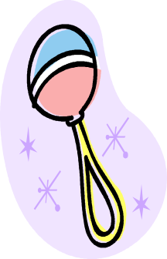
Autobiography Project
My First Years Planning Page

Interview your parent(s) or other relatives to gather the following information. Be sure to also gather pictures to add to your autobiography of these topics and/or from your first 4 years of life.

- Where were you born (city, state, and hospital)? __________________________________________________________
- Weight at birth: _______________________________________________
- Length at birth:_______________________________________________
- What were some of the reactions to your birth? (include comments, quotes, and feelings of different relatives) _____________________________________ ________________________________________________________________________________________________________________________________________________________________________________________________________________________________________
- Interesting stories or events from the day you were born (could be from your family or around the state/world): _______________________________________ ____________________________________________________________________________________________________________________________________________________________________________________________________________________________________________________________________________________________________________________________________________________________
- What kind of baby/toddler were you? ________________________________
- Did you have a special toy, blanket, or object? If so, what was it? __________________________________________________________
- First word: __________________________________________________
- First solid food: _______________________________________________
- Age and/or date of first haircut: ____________________________________
- Other “firsts”: ________________________________________________

*When you’re writing you’re My First Years Page, gather as much information as you can from different relatives. Include anything else you find interesting and want as a memory that might not be listed here. Include events up to age 4. Use the back of this page to take notes or record the information.

Name :__________________________________________ Date: ________

Autobiography Project
My First Years Writing Checklist

Directions: Use the information you gathered to write a personal narrative about your “First Years.” Be sure you use 1st person and make all verbs past tense. Use the checklist to guide you as you do your writing. Check it again after you finish your writing!

Introduction
- used dialogue and/or figurative language for opening
- date, time, and place of birth
- weight & length at birth
Body Paragraphs
- included reactions of family members
- described special memories and “firsts”
- used 1 paragraph for each topic
Closing
- described what kind of baby/toddler you were
- included a creative closing
Format
- used past tense verbs
- used 1st person
- proper use of capitalization, punctuation, spelling, and grammar

Name: __________________________________________ Date: ________

Autobiography Project
My First Years Writing Checklist

Directions: Use the information you gathered to write a personal narrative about your “first years.” Be sure you use 1st person and make all verbs past tense. Use the checklist to guide you as you do your writing. Check it again after you finish your writing!

Introduction
- used dialogue and/or figurative language for opening
- date, time, and place of birth
- weight & length at birth
Body Paragraphs
- included reactions of family members
- described special memories and “firsts”
- used 1 paragraph for each topic
Closing
- described what kind of baby/toddler you were
- included a creative closing
Format
- used past tense verbs
- used 1st person
- proper use of capitalization, punctuation, spelling, and grammar
Name: ________________________________________________ Date: _________

Autobiography Project
My Friends Planning Page

Fill in the following information about your friends. This is just for your notes so it does not have to be complete sentences. Gather pictures of your friends also to add to your autobiography.

- Describe in your own words what friendship means to you. ___________________________________________________________________________________________________________________________________________________________________________________________________________________________________________________
- List the names of your closest friends. Describe what it is you like most about each of those friends. Remember to use descriptive character traits and don’t be repetitive!
Name Description/Traits
__________________ ________________________________
__________________ ________________________________
__________________ ________________________________
__________________ ________________________________
__________________ ________________________________
- Choose 2-3 brief stories to highlight about your friends. You may choose to write about a special vacation, school trip, how you met, etc. ___________________________________________________________________________________________________________________________________________________________________________________________________________________________________________________________________________________________________________________________________________________________________________________________________________________________________________________________________________________________________________________________________________________________________________________________________________________________________________________________________________________________________________________________________________________________________________________________________________________________________________________________________________________________________________________________________________________

Name :________________________________________________ Date: _________
Autobiography Project
My Friends Writing Checklist

Directions: Use the information you gathered to write a personal narrative about your friends. Be sure you use 1st person. Use the checklist to guide you as you do your writing. Check it again after you finish your writing!

Introduction
- used creative opening
- described how friends make you feel
Body Paragraphs
- introduced friends and described them
- told stories about your friends
- used a new paragraph for each topic
Closing
- stated overall opinion of your friends using different words than you have already
Format
- used 1st person
- proper use of capitalization, punctuation, spelling, and grammar

Name : ________________________________________________ Date: _________
Autobiography Project
My Friends Writing Checklist

Directions: Use the information you gathered to write a personal narrative about your friends. Be sure you use 1st person and be descriptive. Use the checklist to guide you as you do your writing. Check it again after you finish your writing!

Introduction
- used creative opening
- described how friends make you feel
Body Paragraphs
- introduced friends and described them
- told stories about your friends
- used a new paragraph for each topic
Closing
- stated overall opinion of your friends using different words than you have already
Format
- used 1st person
- proper use of capitalization, punctuation, spelling, and grammar

Name :________________________________________________ Date: _________
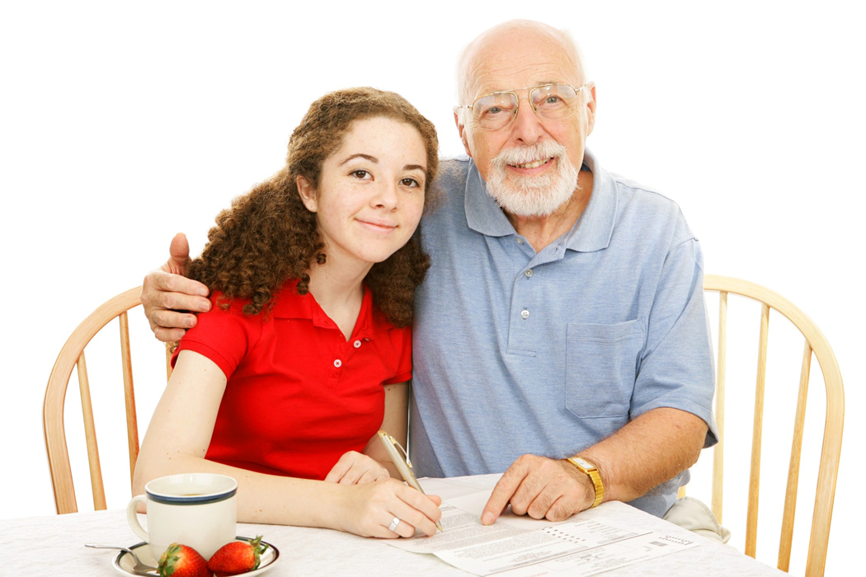
Autobiography Project
My Family Planning Page

Interview your parent(s) or other relatives to gather the following information if needed. Be sure to also gather pictures to add to your autobiography of these topics and your family.

- List the names of your immediate family members (parents, grandparents, siblings) and ages of any siblings. __________________________________________________________________________________________________________________________
- List the names of your extended family members (cousins, aunts, uncles) that you’d like included in your autobiography. __________________________________________________________________________________________________________________________
- Describe in your own words what family means to you. _________________________________________________________________________________________________________________________________________________________________________________________________________________________________________________________________________________________________________________
- Choose 2-3 brief stories to highlight about your family. Write a few facts about each story. You may choose to write about a special vacation, birth of a sibling, tradition, etc. Use the back of the page if needed. ______________________________________________________________________________________________________________________________________________________________________________________________________________________________________________________________________________________________________________________________________________________________________________________________________________________________________________________________________________________________________________________________________________________________________________________________________________________________________________________________________________________________________________________________________________________________________________________________________________________________________________________________________________________

Name :________________________________________________ Date: _________
Autobiography Project
My Family Writing Checklist

Directions: Use the information you gathered to write a personal narrative about your family. Be sure you use 1st person. Use the checklist to guide you as you do your writing. Check it again after you finish your writing!

Introduction
- used creative opening
- described how family makes you feel
Body Paragraphs
- introduced immediate family members names, ages (where appropriate) and relation to you
- introduced extended family members names, ages (where appropriate) and relation to you
- told stories about family
- used a new paragraph for each topic
Closing
- stated overall opinion of your family using different words than you have already
Format
- used 1st person
- proper use of capitalization, punctuation, spelling, and grammar

Name :________________________________________________ Date: _________
Autobiography Project
My Family Writing Checklist

Directions: Use the information you gathered to write a personal narrative about your family. Be sure you use 1st person. Use the checklist to guide you as you do your writing. Check it again after you finish your writing!

Introduction
- used creative opening
- described how family makes you feel
Body Paragraphs
- introduced immediate family members names, ages (where appropriate) and relation to you
- introduced extended family members names, ages (where appropriate) and relation to you
- told stories about family
- used a new paragraph for each topic
Closing
- stated overall opinion of your family using different words than you have already
Format
- used 1st person
- proper use of capitalization, punctuation, spelling, and grammar

Name :______________________________________________ Date: ___________
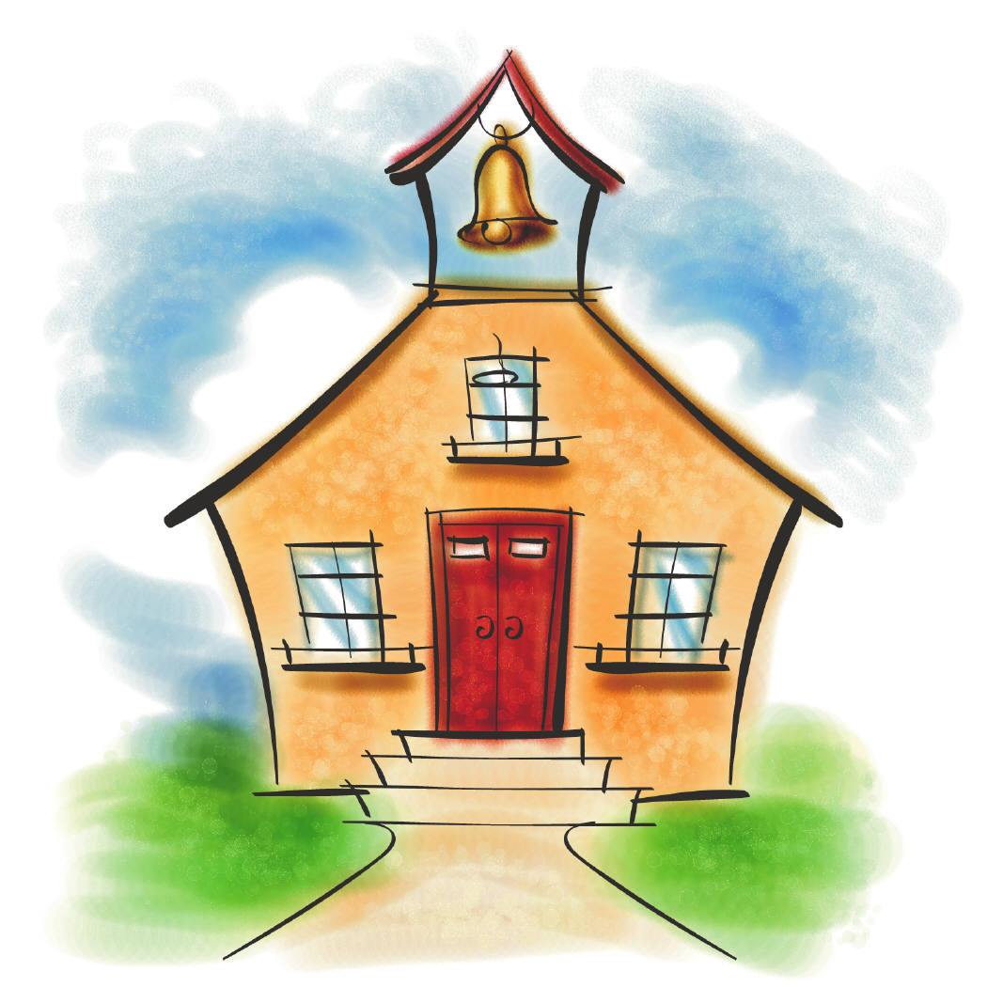
Autobiography Project
School Planning Page

Use this page to help you prepare for the writing of your School Page. Add any additional details you would like to for each grade. Include as much detail as possible for each grade level. You will use this information to write a personal narrative. Gather pictures for each year of school (if possible) to include in the autobiography.

Kindergarten
Teacher’s name: _____________________________________________________
School: ____________________________________________________________
Friends: ____________________________________________________________
School Trip/Project: ___________________________________________________
Favorite subject(s): ____________________________________________________
Other memories/facts/stories: ____________________________________________ ____________________________________________________________________________________________________________________________________________________________________________________
1st Grade
Teacher’s name: _____________________________________________________
School: ____________________________________________________________
Friends: ____________________________________________________________
School Trip/Project: ___________________________________________________
Favorite subject(s): ____________________________________________________
Other memories/facts/stories: ____________________________________________ ____________________________________________________________________________________________________________________________________________________________________________________
2nd Grade
Teacher’s name: _____________________________________________________
School: ____________________________________________________________
Friends: ____________________________________________________________
School Trip/Project: ___________________________________________________
Favorite subject(s): ____________________________________________________
Other memories/facts/stories: ____________________________________________ ____________________________________________________________________________________________________________________________________________________________________________________

3rd Grade
Teacher’s name: _____________________________________________________
School: ____________________________________________________________
Friends: ____________________________________________________________
School Trip/Project: ___________________________________________________
Favorite subject(s): ____________________________________________________
Other memories/facts/stories: ____________________________________________ ____________________________________________________________________________________________________________________________________________________________________________________
4th Grade
Teacher’s name: _____________________________________________________
School: ____________________________________________________________
Friends: ____________________________________________________________
School Trip/Project: ___________________________________________________
Favorite subject(s): ____________________________________________________
Other memories/facts/stories: ____________________________________________ ____________________________________________________________________________________________________________________________________________________________________________________
WMS
Favorite Teacher’s: ___________________________________________________________________________________________________________________________________
School: ____________________________________________________________
Friends: ____________________________________________________________
School Trip/Project: ___________________________________________________
Favorite subject(s): ____________________________________________________
Other memories/facts/stories: ____________________________________________ ________________________________________________________________________________________________________________________
Name :_____________________________________________ Date: ____________
Autobiography Project
School Page Writing Checklist

Directions: Use the information you gathered on your School Planning Page to write a personal narrative about your school years. Be sure you use 1st person and make all verbs past tense (unless referring to current events in 8th grade). Use the checklist to guide you as you do your writing. Check it again after you finish!

Introduction
- included a creative opening
- described thoughts in general about school years
Body Paragraphs
- wrote 1 paragraph per grade level
- described key details about each grade level
Closing
- included a creative closing
- restated thoughts about school years
Format
- used 1st person
- used past tense verbs for grades other than 8th
- used present tense verbs for 8th grade
- correct capitalization, punctuation, spelling, and grammar used

Name: _____________________________________________ Date: ____________
Autobiography Project
School Page Writing Checklist

Directions: Use the information you gathered on your School Planning Page to write a personal narrative about your school years. Be sure you use 1st person and make all verbs past tense (unless referring to current events in 8th grade). Use the checklist to guide you as you do your writing. Check it again after you finish!

Introduction
- included a creative opening
- described thoughts in general about school years
Body Paragraphs
- wrote 1 paragraph per grade level
- described key details about each grade level
Closing
- included a creative closing
- restated thoughts about school years
Format
- used 1st person
- used past tense verbs for grades other than 8th
- used present tense verbs for 8th grade
- correct capitalization, punctuation, spelling, and grammar used

Name: ________________________________________________ Date: _________

Autobiography Project
Personality Page

My Personality Traits:
Create a list of traits that describe you best. Remember to use as many as you can so you can look back and get a great idea of what kind of person you were in 8th grade. Be honest about your traits!

Examples:
Give examples for each character trait you listed. An example might be that you tried surfing for the first time. This may demonstrate that you are adventurous or active. You might write about a time that you helped out a relative in need, which demonstrates that you are helpful and/or kind.

TRAIT | EXAMPLE

Now give the bottom part of this to one or two of your friends. Ask them to come up with some traits about you and some examples.

TRAIT | EXAMPLE

Take all of these traits and examples and create a Personality Page in whatever style you choose! Be creative and have fun with it!
Name :________________________________________________ Date: _________

Autobiography Project
Favorites Page

Fill in the chart below with some of your favorites. If you don’t have a favorite for a particular category, you can leave it blank. You can also add other favorite categories if you wish in the blank rows.

CATEGORY | YOUR FAVORITE
Color
Food
Ice Cream
Drink
Subject
Board Game
Video Game
Fiction Book
Nonfiction Book
Movie
TV Show
Animal
Sport
Restaurant
Song
Singer/Band

Take all of these favorites and create a page in whatever style you choose! Be creative and have fun with it!

Name :________________________________________________ Date: _________

Autobiography Project
Future Planning Page

Family:
- In the future, where do you think you would like to live (city, state, country)? _____________________________________________________________
- Do you think you will get married? ___Yes ___No
- Do you think you will have any kids? _____ If yes, how many? __________
Education:
- Will you continue your education after high school? ___ Yes ___No
- If yes, do you have a particular school you’d like to go to after high school? What type of school is it (trade, business, 2-year college, 4-year college/university)? _____________________________________________________________
- Will you go to medical school, law school, or graduate school? If so, which one? _____________________________________________________________
Career:
- What would you like to do for a living? Explain why you chose what you did. ____________________________________________________________________________________________________________________________________________________________________________________________________________________________________________________
Goals:
- What goals do you have for your future? How will you accomplish them? __________ ____________________________________________________________________________________________________________________________________________________________________________________________________________________________________________________
World Events:
- What will the future hold for our town/state/country/world? Describe what changes we will see, and what will stay the same. ___________________________________ ____________________________________________________________________________________________________________________________________________________________________________________________________________________________________________________
Crest:
Design a “future crest” by drawing pictures to illustrate your future in the following four categories: Family, Career, Education, and World. See template on the other side.
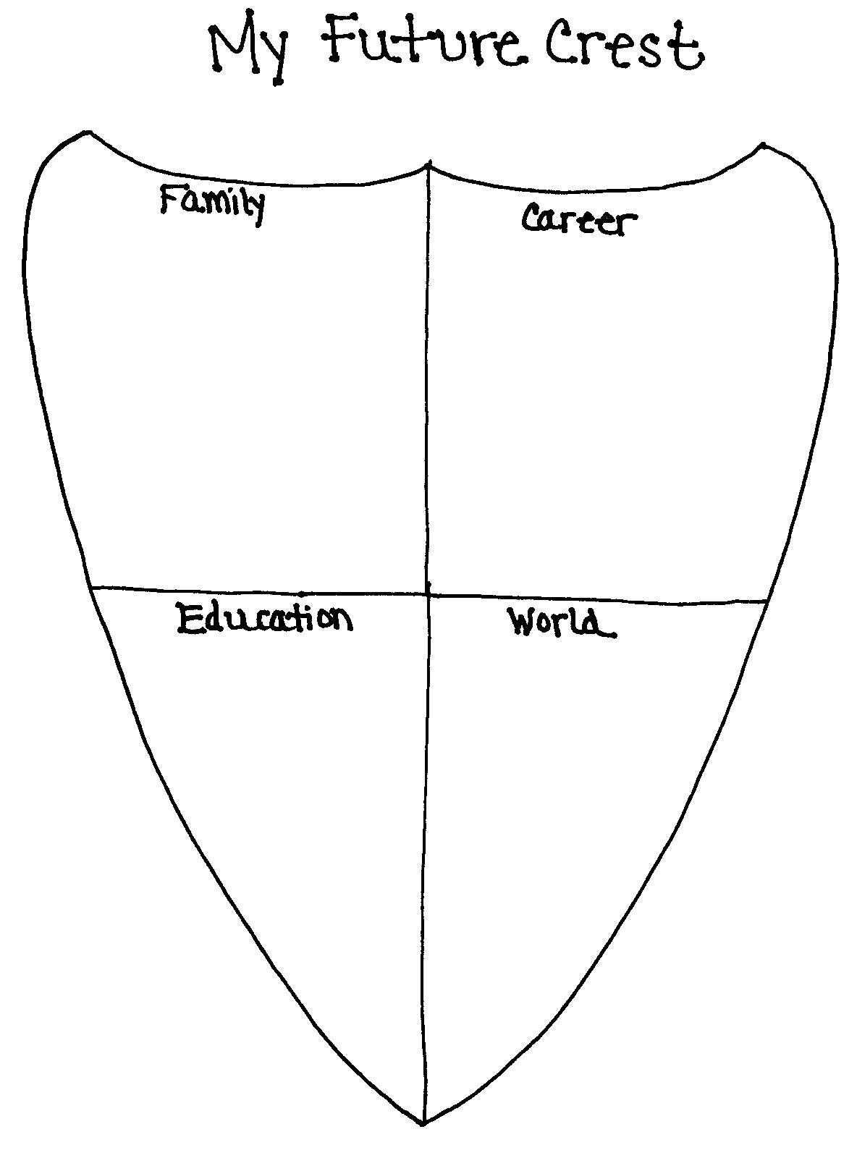
Name: _____________________________________________ Date: ____________
Autobiography Project
Future Page

Directions: Use the information you gathered on your Future Planning to write a personal narrative about your future. Be sure you use 1st person and make all verbs future tense. Use the checklist at the bottom of the page to guide you as you do your writing. Check it again after you finish!

Introduction
- used creative opening
- described how you feel about the future
Body Paragraphs (1-2 paragraphs per topic)
- described the kind of family you will have
- described the type of education you will get
- described your future career
- described your goals & how you’ll accomplish them
- described how things will be the same or different in the future
Closing
- stated overall opinion of your future using different words than you have already
Format
- used 1st person & future tense verbs
- proper use of capitalization, punctuation, spelling, and grammar

Name :_____________________________________________ Date: ____________
Autobiography Project
Future Page

Directions: Use the information you gathered on your Future Planning to write a personal narrative about your future. Be sure you use 1st person and make all verbs future tense. Use the checklist at the bottom of the page to guide you as you do your writing. Check it again after you finish!

Introduction
- used creative opening
- described how you feel about the future
Body Paragraphs (1-2 paragraphs per topic)
- described the kind of family you will have
- described the type of education you will get
- described your future career
- described your goals & how you’ll accomplish them
- described how things will be the same or different in the future
Closing
- stated overall opinion of your future using different words than you have already
Format
- used 1st person & future tense verbs
- proper use of capitalization, punctuation, spelling, and grammar

Name :_____________________________________________ Date: ____________

Autobiography Project
Possible Additions

The final pages of your autobiography are up to you! Choose as many of the topics listed below and create a page for each. Once you’ve made your decision, write a personal narrative for each topic. Be sure to title your writing. You can use pictures as inspiration for your writing and should add some to each page when it is complete. Remember the basics of good writing: introduction, details, and conclusion. If you have an idea for a page that you don’t see listed, feel free to add it!

- Sports
- Hobbies, Collections, or Interests
- Pets Through the Years
- My Greatest Achievement(s)
- My Best Friend and I
- A Special Ancestor, Relative or Hero
- Travels and Vacations
- My Favorite Place in the World
- My Involvement in My Church, Community, etc.
- My Own Artwork/Writing
- Holidays

Name: ________________________________________Date ___________

Autobiography Project
Rubric

You have created a keepsake all about you and your life. Below is the rubric on how the written and other graded components will be scored.

Written Pages (70 points)
Each page below is worth 10 points (7 for writing, 2 for layout, & 1 for corresponding pictures). Criteria for each page that was discussed in class must have been followed for full credit. Proper grammar, spelling, and punctuation are also needed for full credit.

My First Years ____/10 pts.
Family ____/10 pts.
Friends ____/10 pts.
Personality ____/10 pts.
School ____/10 pts.
Favorites ____/10 pts.
Future ____/10 pts.

Additional Components (8 points)
Each of the following pages is worth 2 points. Proper grammar, spelling, punctuation and format must have been followed for full credit.

Cover Page ____/5 pts.
Dedication ____/5 pts.
Table of Contents ____/5 pts.
Conclusion ____/5 pts.

Overall Presentation (10 points)
The final product is a published book of your life up until now! It should look neat, be free of errors, be put together so people can easily read it, and look like something you took pride in producing. Your autobiography should represent you!

POINTS EARNED
Written Pages = ____________/70 points
Additional Components = ____________/20 points
Overall Presentation = ____________/10 points

TOTAL = _____________/100 POINTS

